**Name: Do Duy Anh Web Application Lab**

**ID: ITCSIU21163**

**LAB 2**



Figure . Favicon

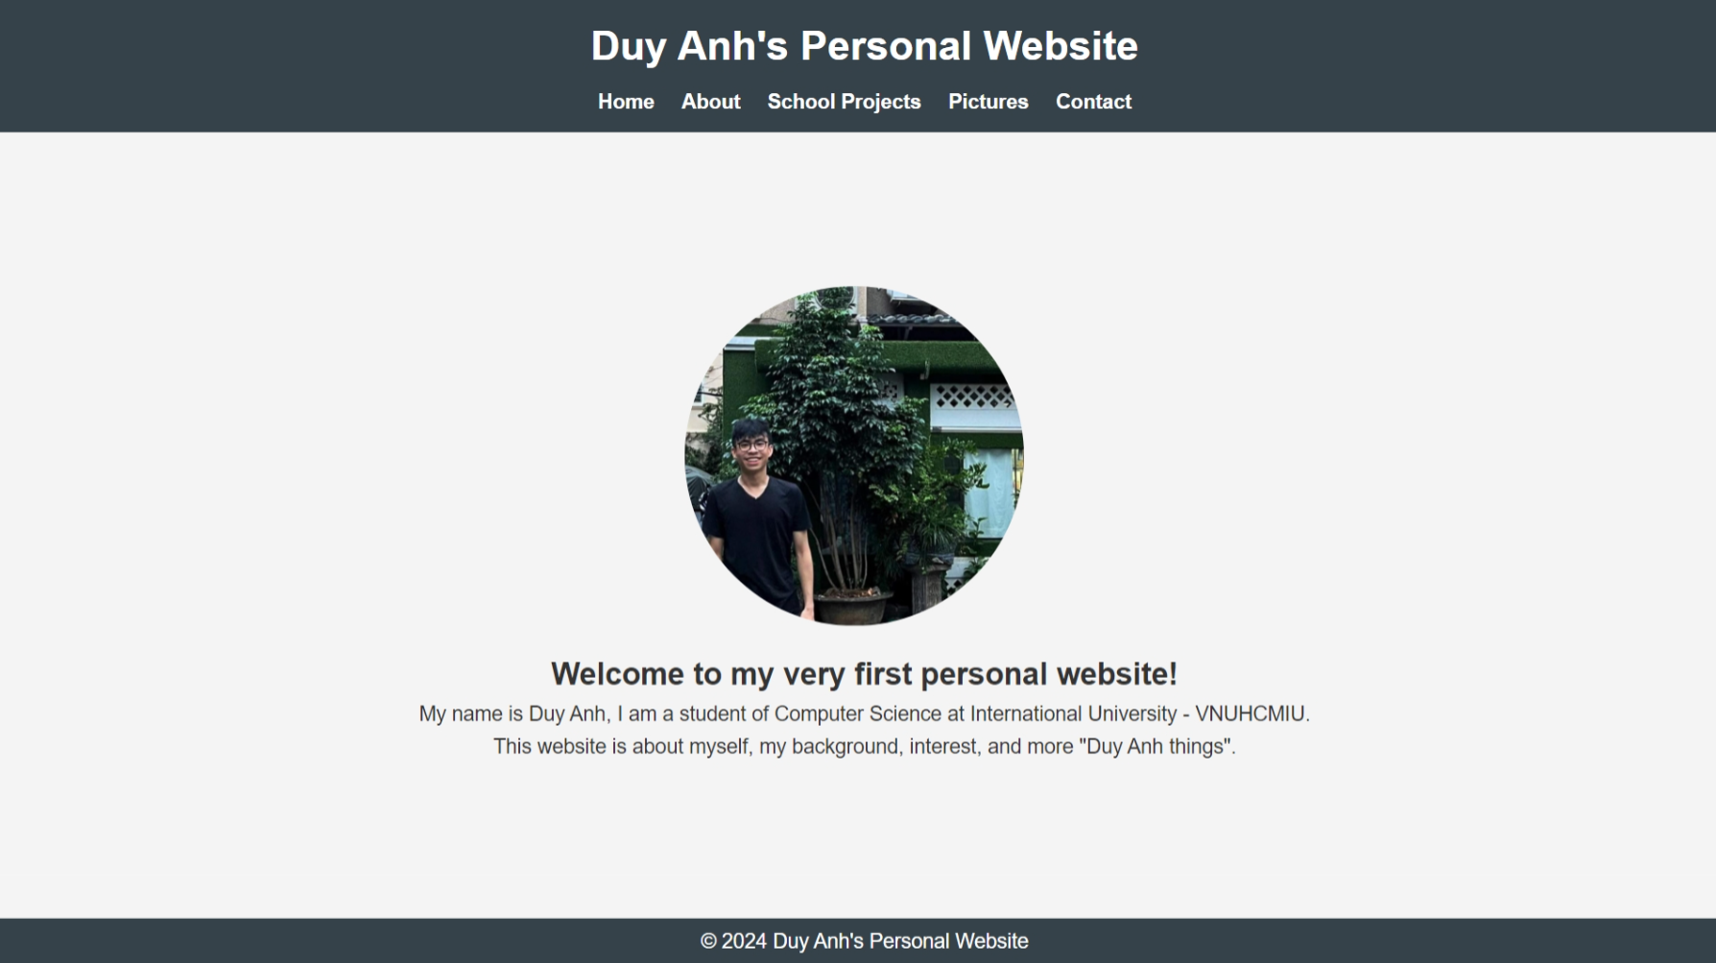

Figure . Home page

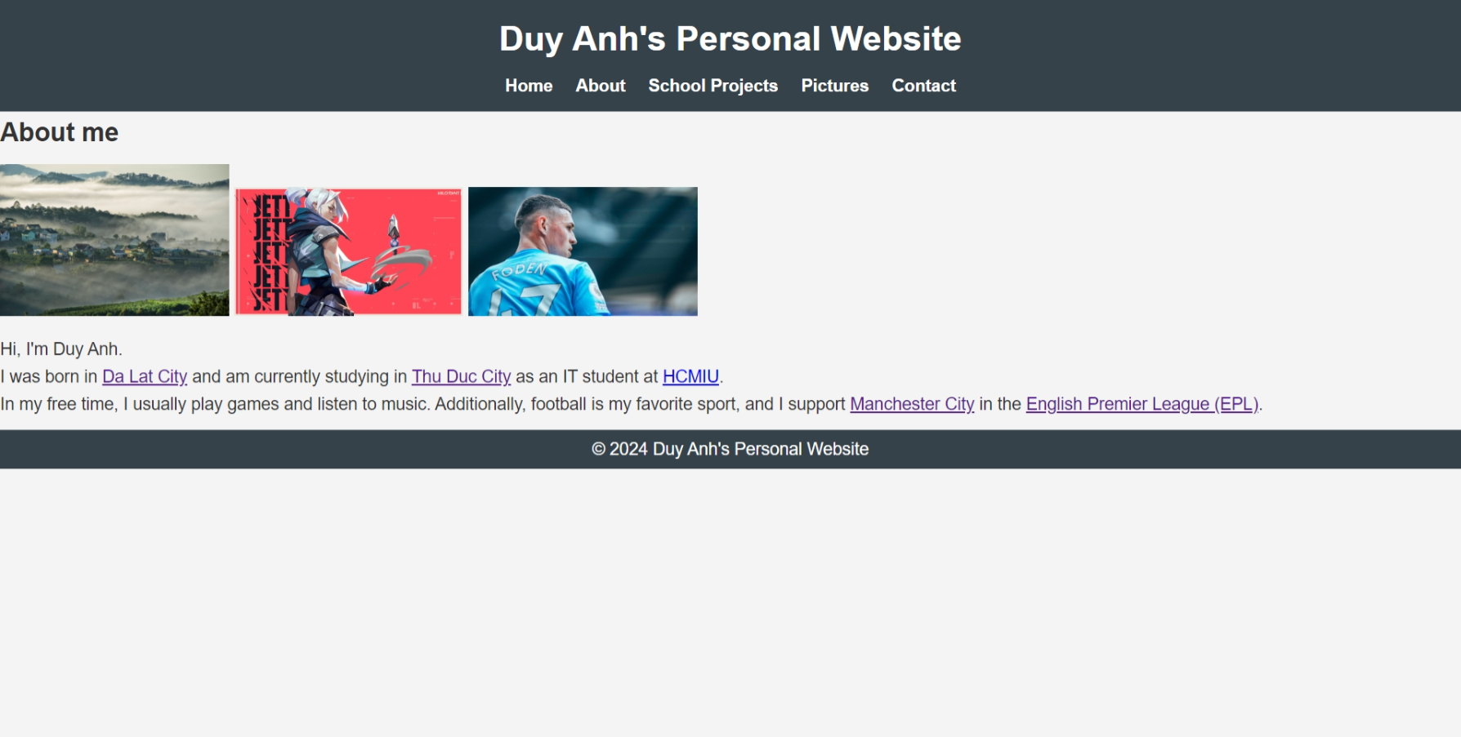

Figure . About page with clickable text

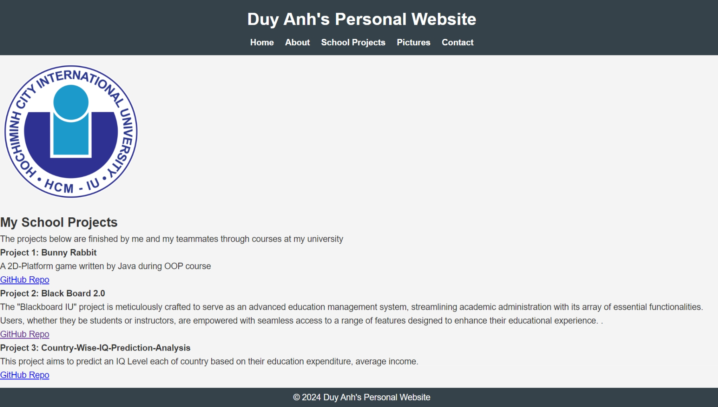

Figure . School Projects page with clickable Github Repo

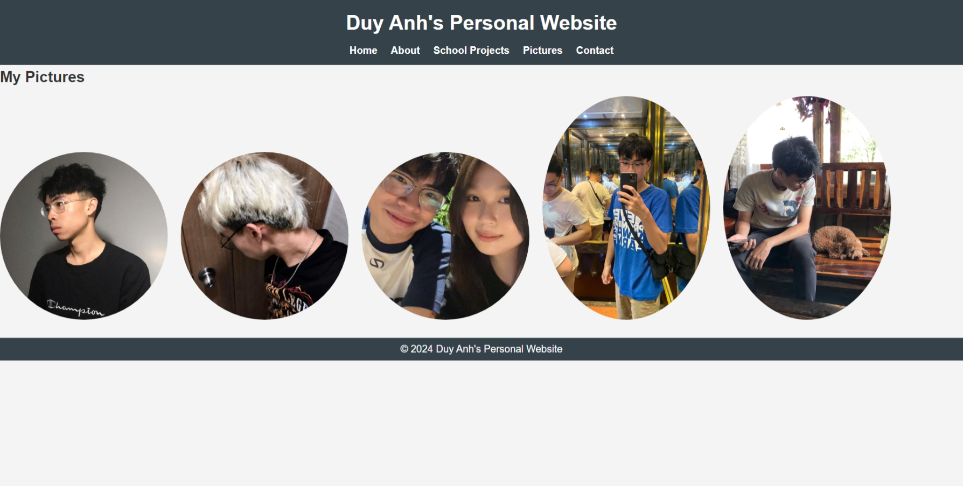

Figure . Pictures page

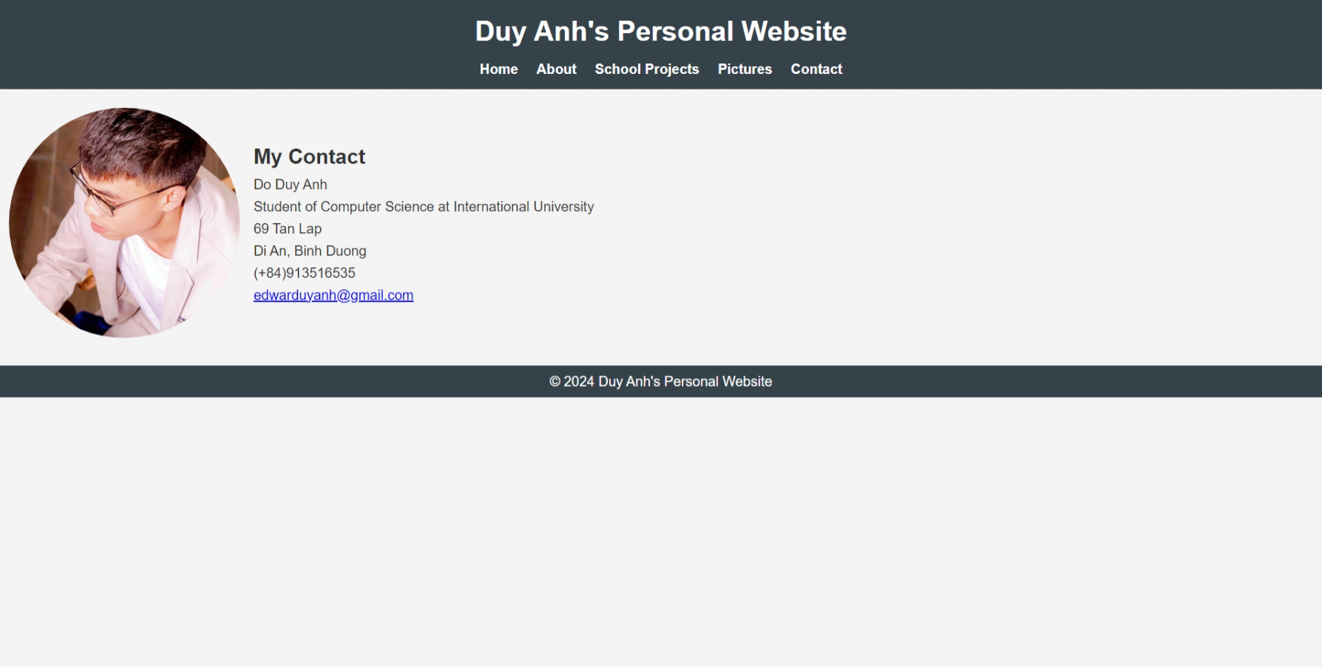

Figure . Contact page with clickable Email